# Web App Design with React Week 3 Coding Assignment

**Points possible:** 70

|  |  |  |
| --- | --- | --- |
| Category | Criteria | % of Grade |
| Functionality | Does the code work? | 25 |
| Organization | Is the code clean and organized? Proper use of white space, syntax, and consistency are utilized. Names and comments are concise and clear. | 25 |
| Creativity | Student solved the problems presented in the assignment using creativity and out of the box thinking. | 25 |
| Completeness | All requirements of the assignment are complete. | 25 |

**Instructions:** In VS Code, or an IDE of your choice, write the code that accomplishes the objectives listed below. Ensure that the code compiles and runs as directed. Take screenshots of the code and of the running program (make sure to get screenshots of all required functionality) and paste them in this document where instructed below. Create a new repository on GitHub for this week’s assignments and push this document, with your JavaScript project code, to the repository. Add the URL for this week’s repository to this document where instructed and submit this document to your instructor when complete.

**Coding Steps:**

1. Using the Houses API, or any open API of your choice you can find online, create a single page that allows for all 4 crud operations to be performed on a resource from that API. Create a React component (or more, if needed) to represent the resource. Make all forms and other necessary UI pieces their own components as reasonable.

**Notes on this week’s assignment:**

*I created a One Word app and attempted to interface with Postman API, CrudCrud and the Houses API but could not get post/put to work with any of them. I then tried to change the interface of the Houses API to display the One Word app while keeping the code set to houses and rooms but the add word(room) functionality does not work. Included are screenshots and links to both apps.*

**Word-via-house App: keeping the house/room functions with One Word display**

**Screenshots of Code:**

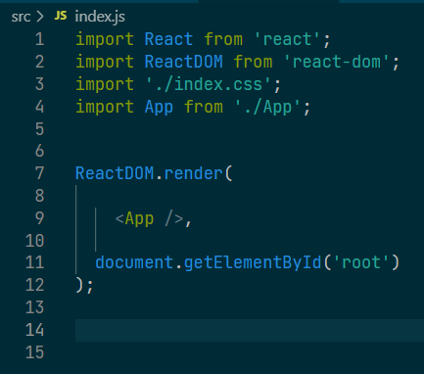

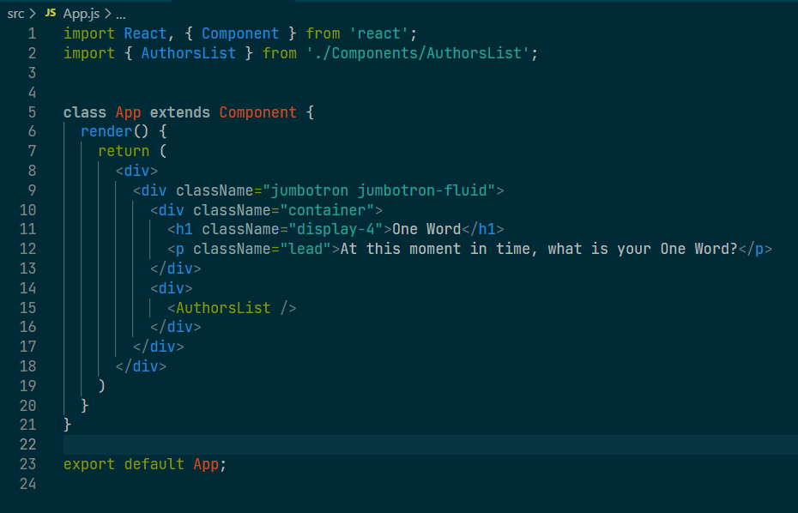

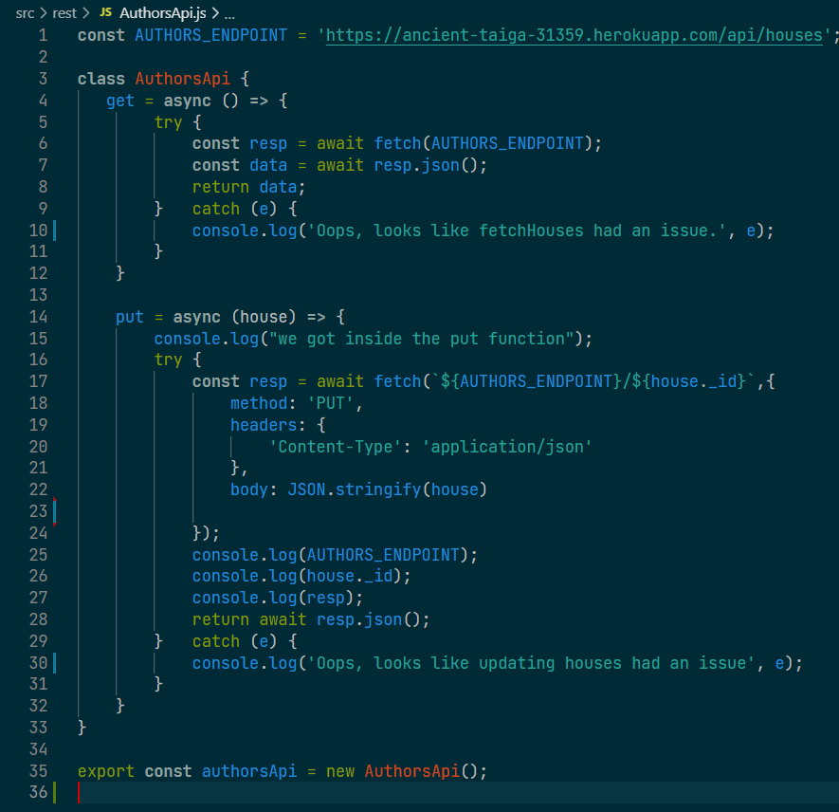

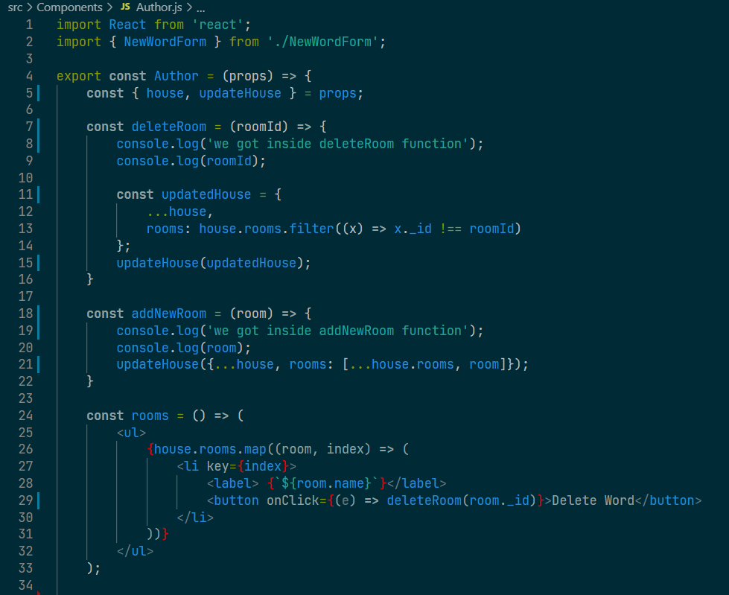

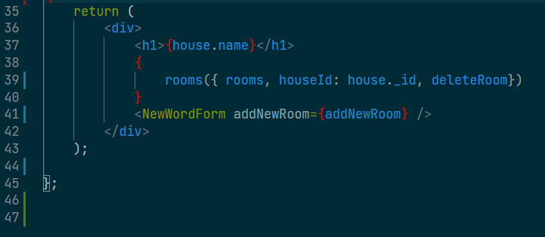

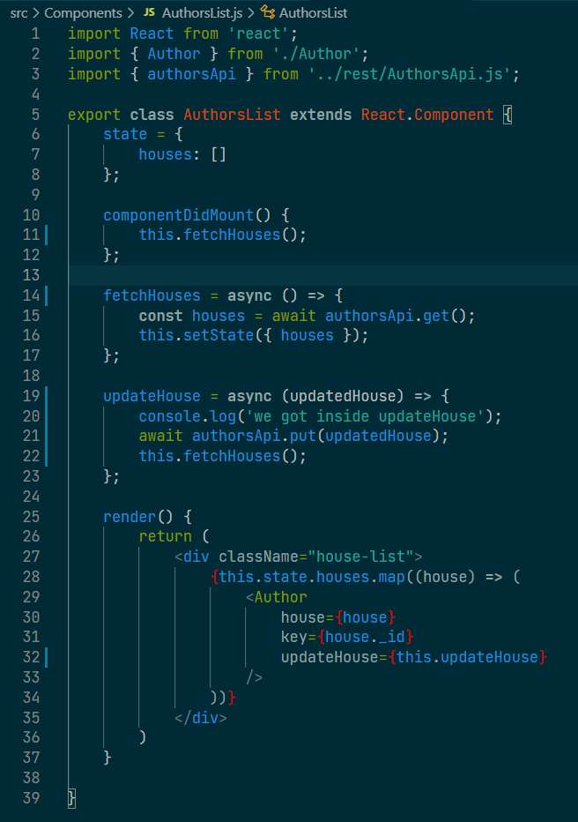

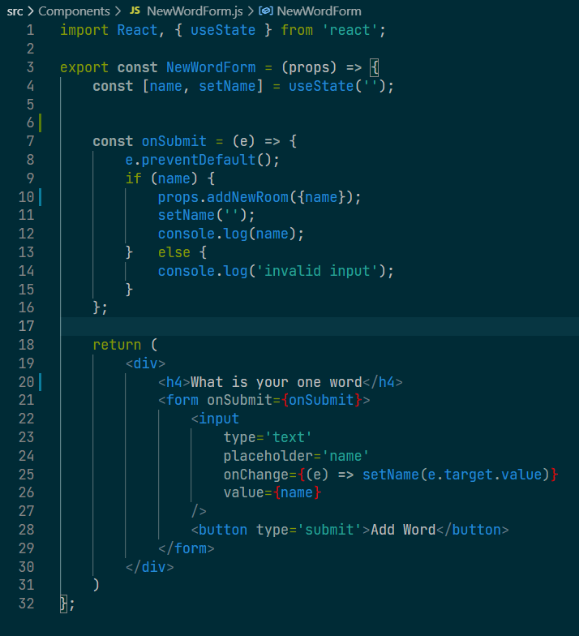

**Screenshots of Running Application:**

Using existing houses API, delete word functionality works, but add word only shows up in the console.

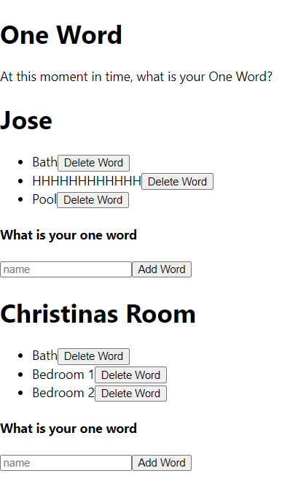 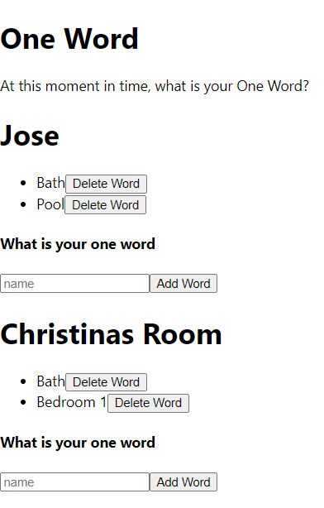

Can add a word in the field but will only display in console, not on screen:

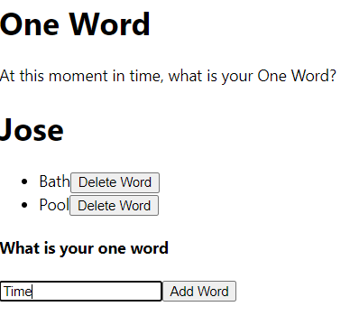

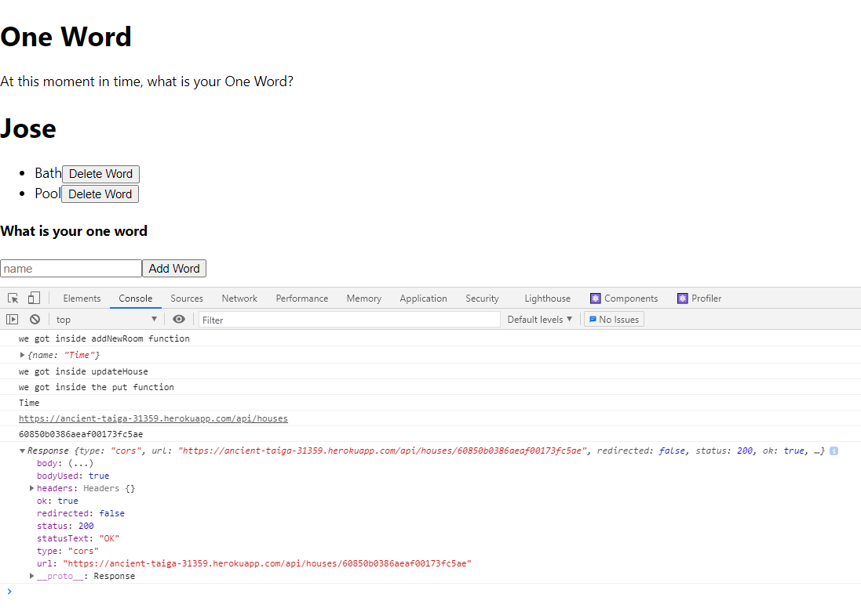

**URL to GitHub Repository:** [**https://github.com/meraki11/words-via-house.git**](https://github.com/meraki11/words-via-house.git)

**One word App: original app for assignment, tried with Postman, CrudCrud and House API but could not get functionality.**

**Screenshots of Code:**

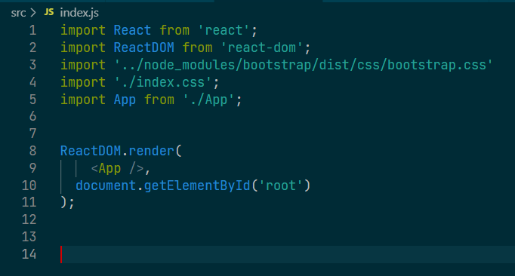

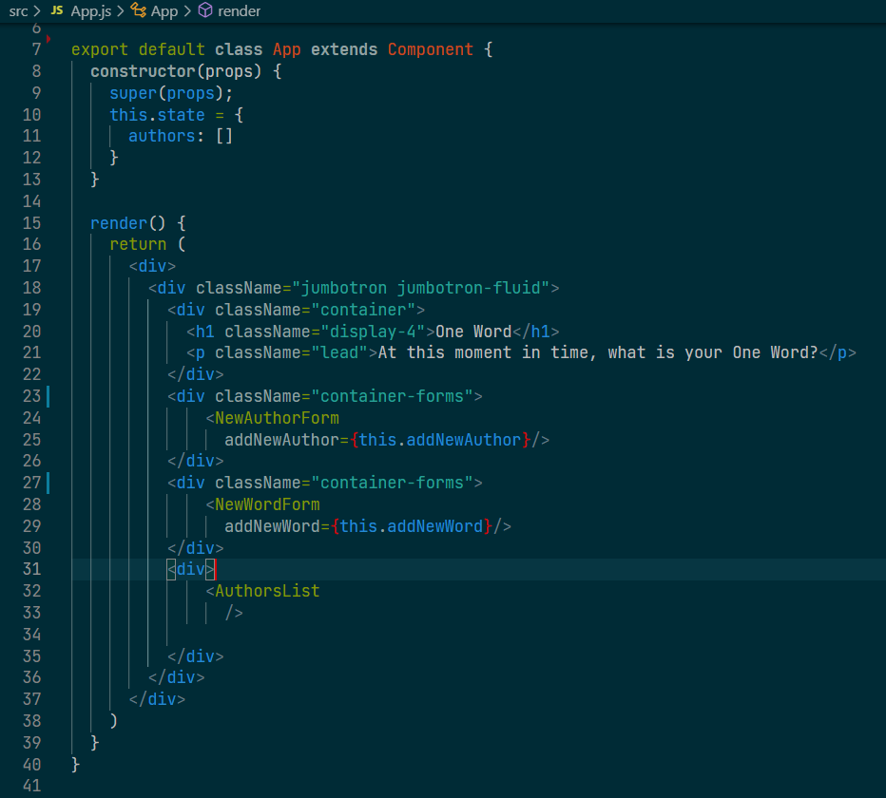

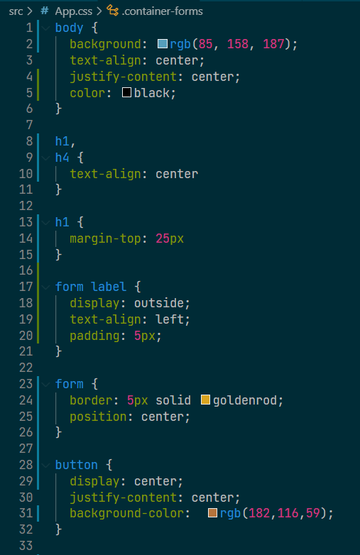

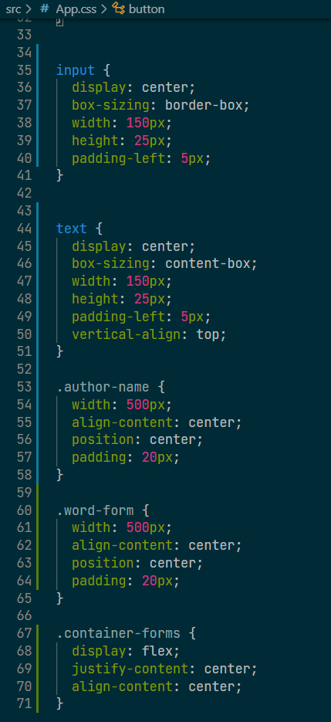

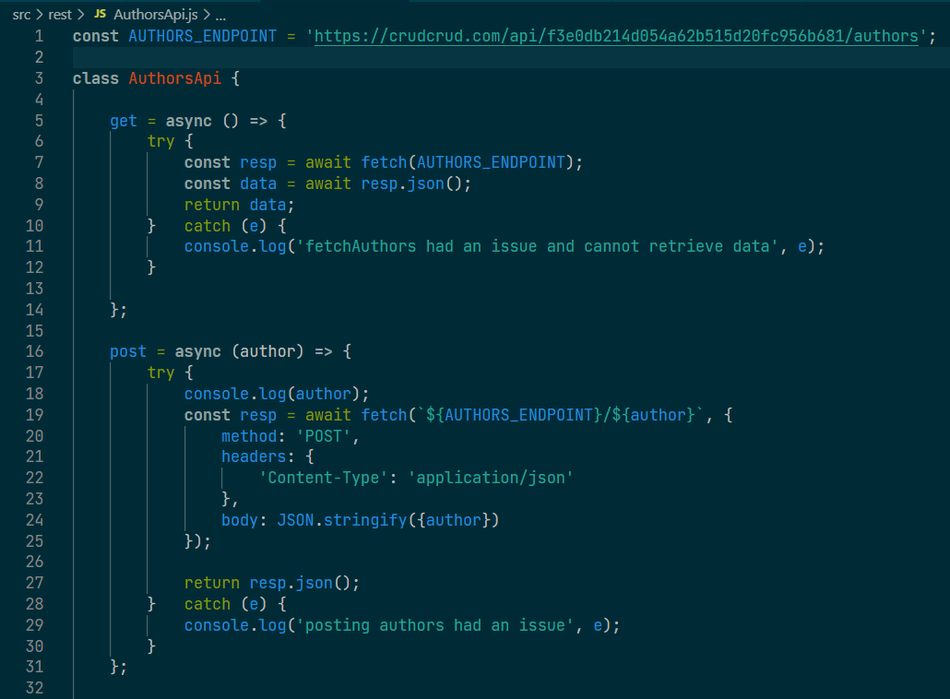

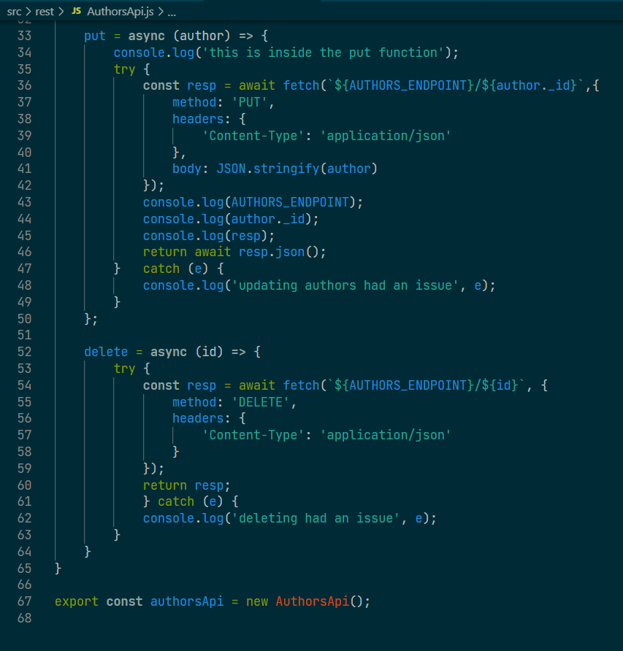

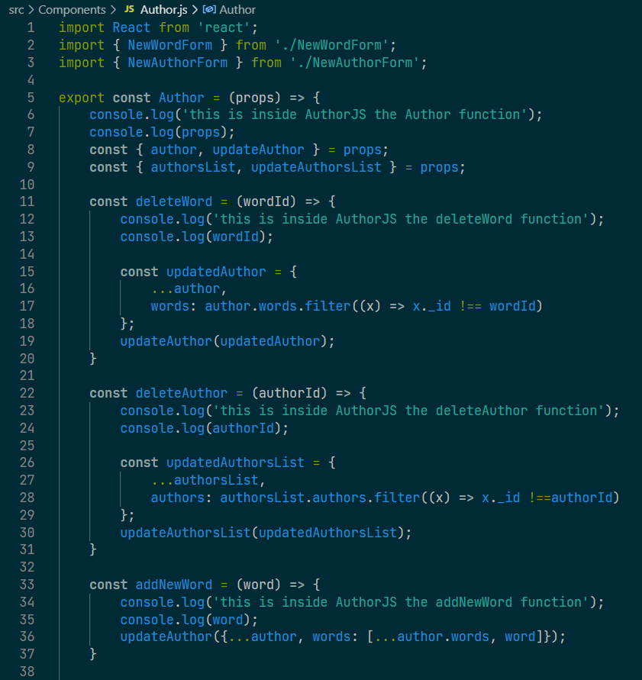

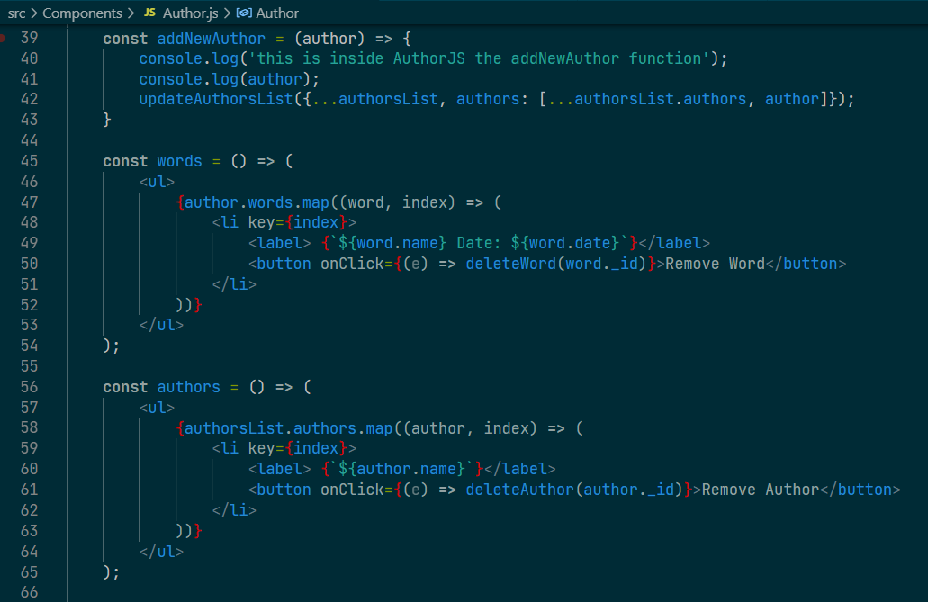

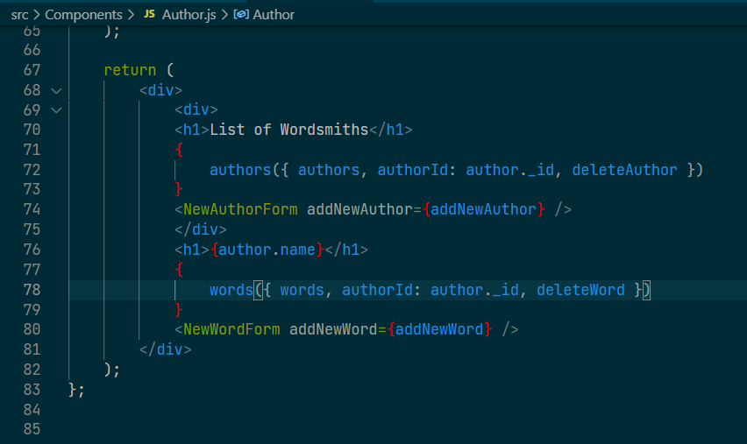

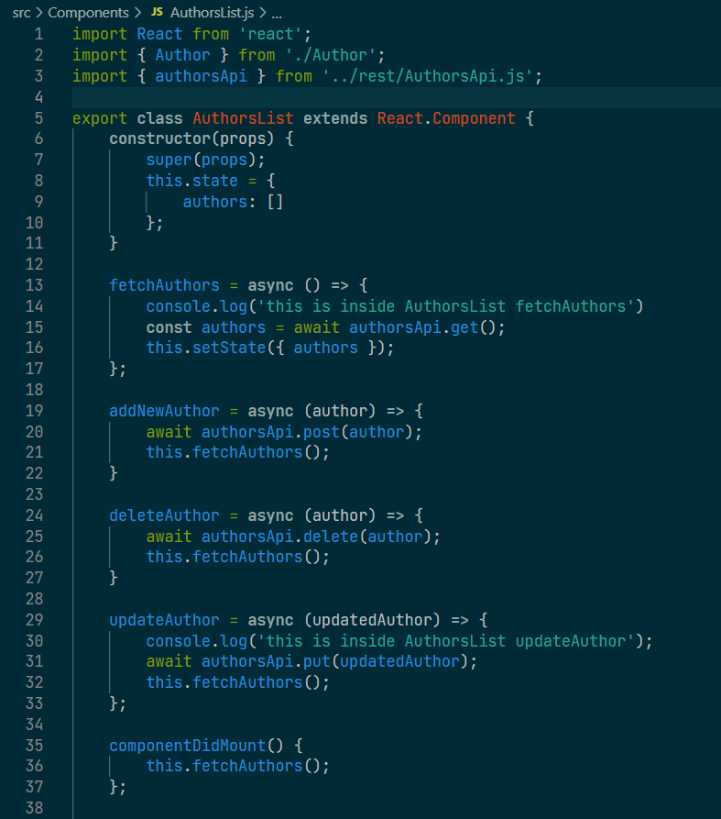

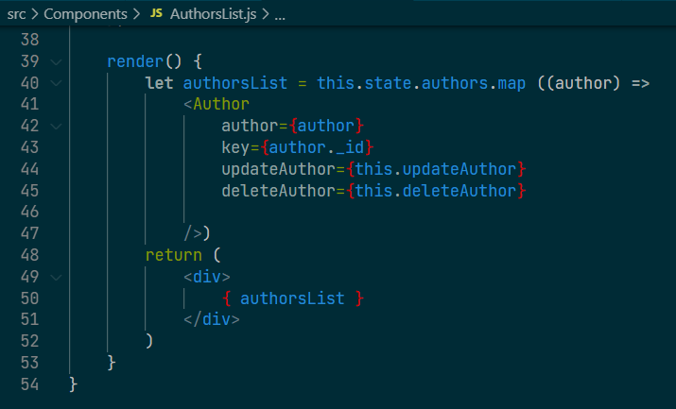

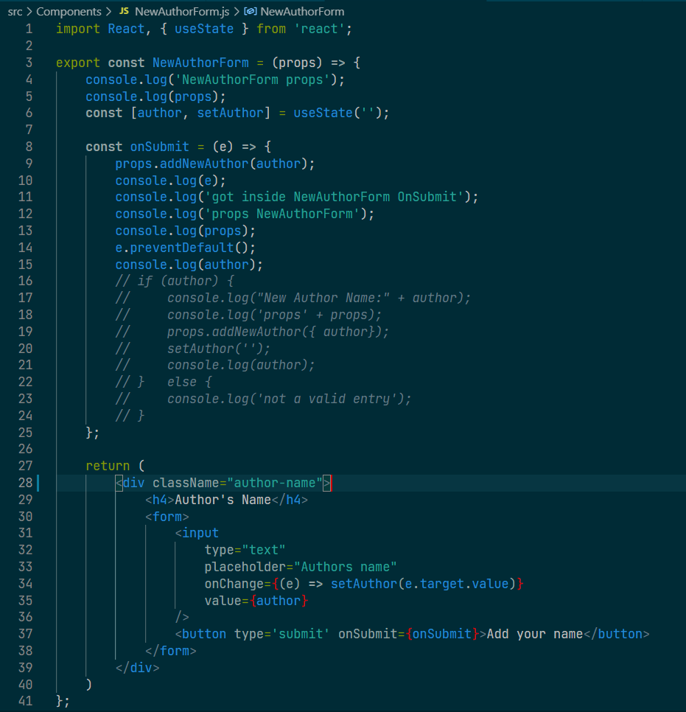

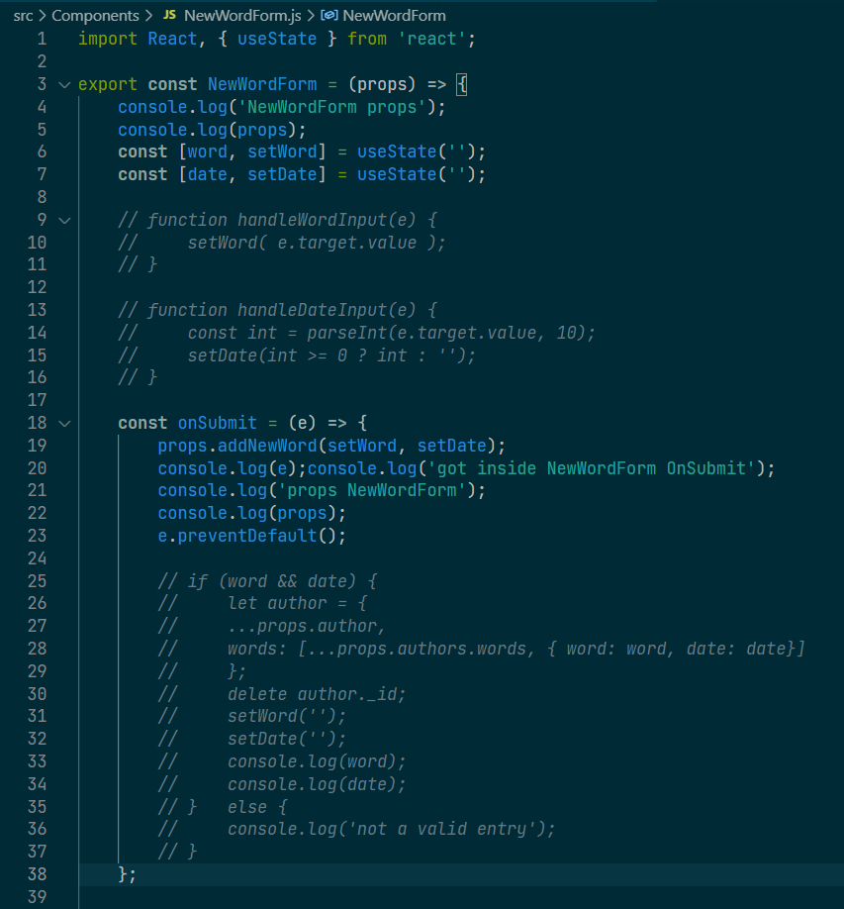

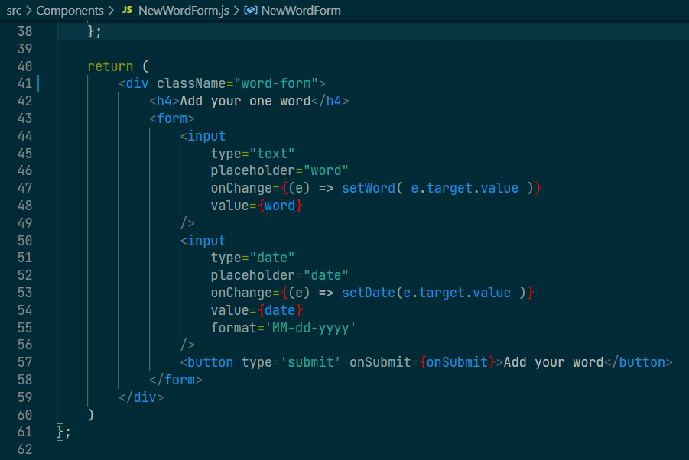

**Screenshots of Running Application:**

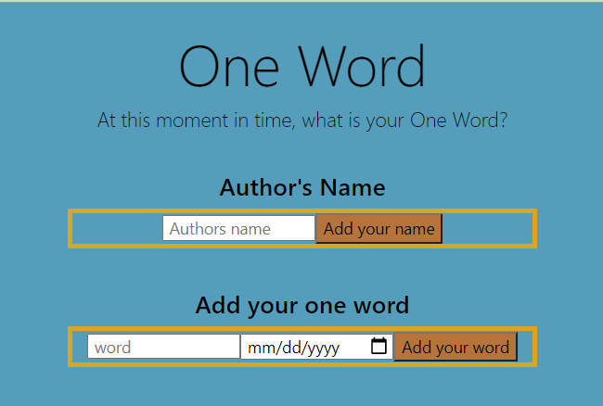

**Enter name:**

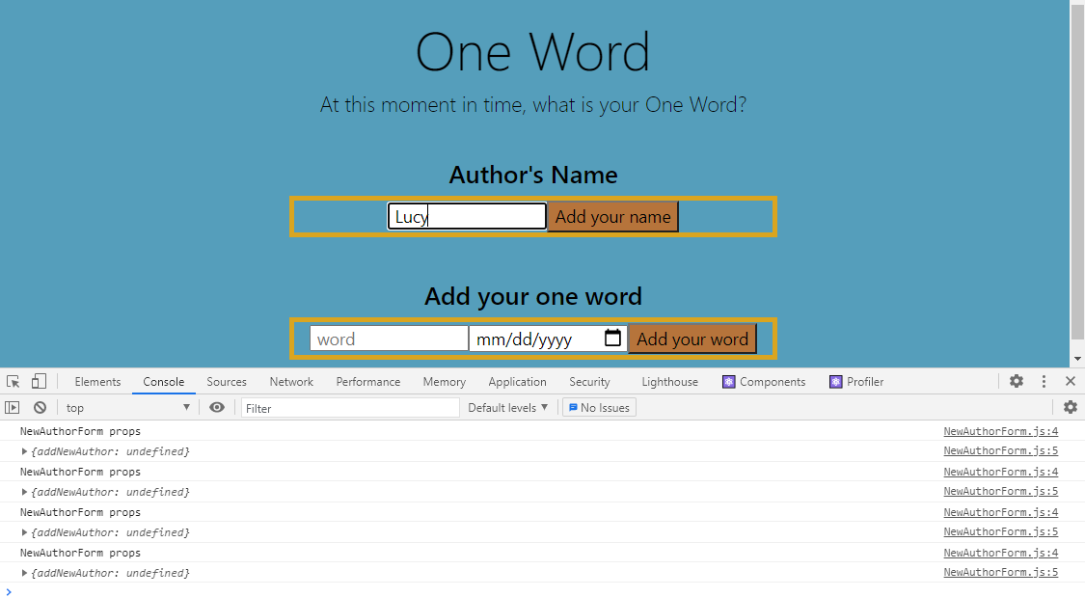

**Name does not display:**

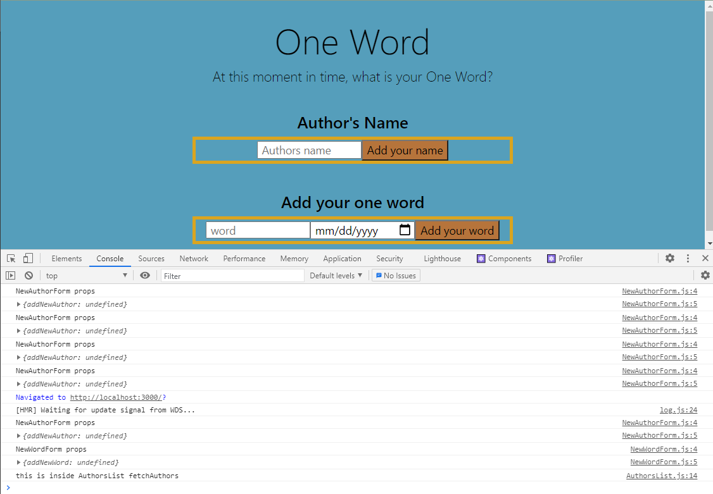

**Enter word:**

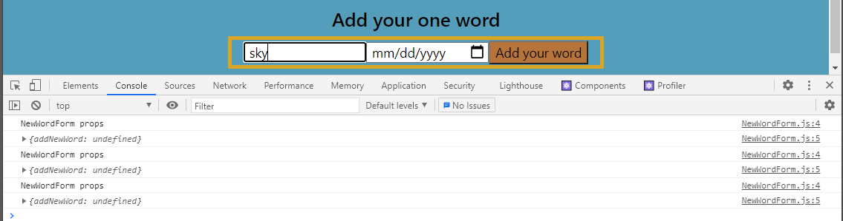

**Word does not display**

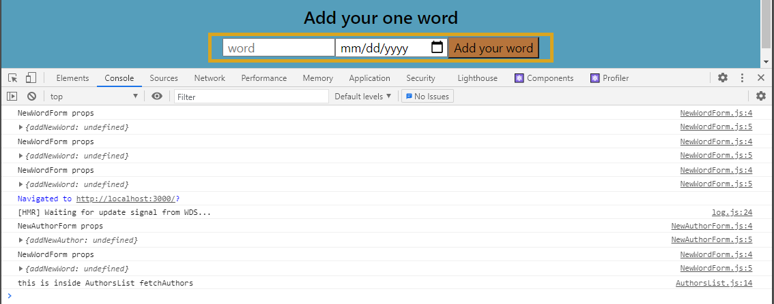

**URL to GitHub Repository:** [**https://github.com/meraki11/react-one-word.git**](https://github.com/meraki11/react-one-word.git)